Volvo Bus Corporation

Press Information

Order received for 126 Nova buses to Vancouver

Volvo Buses’ subsidiary Nova Bus has received an order for 126 city buses to TransLink, in Vancouver, Canada. The order is valued at CAD 50.2 M, with delivery during 2007.

TransLink is the authority responsible for public transportation in the Greater Vancouver area. Seventy-five of the new buses will replace older buses that have been in traffic since the beginning of the 1990s, while the remainder are an addition to the bus fleet. This is a breaktrough for Nova Bus in Vancouver since this is the first big order from TransLink.
The new buses are the Nova LFS model, a 12.2-meter-long low-entry bus. The buses are equipped with the latest generation diesel engines that use ultra-low-sulfur fuel with a particulate exhaust trap. The impact on net air quality was one of the reasons that TransLink chose the Nova LFS. Lifecycle cost was another.
”We had an opportunity to test a Nova Bus in 2005, and we were as impressed with the look and ride as we were with its performance,” says Malcolm Brodie, Chairman of the TransLink Board of Directors.
Nova Bus is a division of Prevost Car Inc., which is a wholly owned subsidiary of Volvo Bus Corporation. Nova Bus is one of the largest manufacturers of city and intercity buses in North America. The company has two plants in Canada.
October 9, 2006
For further information, please contact Per-Martin Johansson, press officer, +46 31 322 52 00.
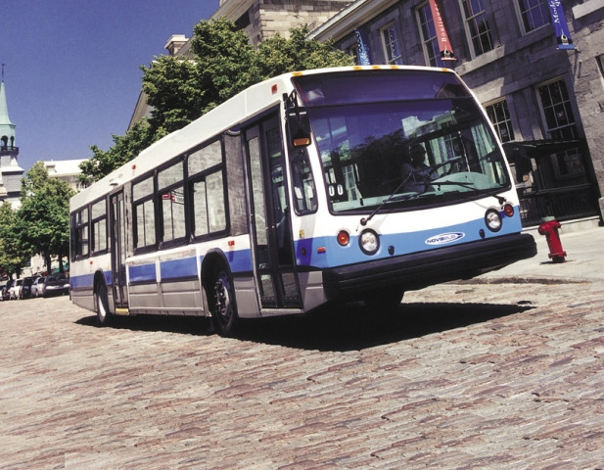
Download picture here

