Volvo Bus Corporation
Press Information

First order for Volvo’s new bi-articulated bus in Mexico

Volvo Buses has received its first order for the new bi-articulated version of the Volvo 7300 in Mexico. The buses will traffic the world’s longest BRT corridor in Mexico City.

Mexico City is at the forefront in Latin America with regard to investment in environmentally sound transportation. The investments include the efficient bus-based transport system, BRT, and a transition to low-sulfur fuels.
Today, Mexico City has the world’s longest BRT corridor, 28.5 kilometers, which connects the southern and northern section of the city. Eleven BRT lines are planned for the next five-year period covering a total of 240 kilometers.
The first line through the city currently uses 135 articulated buses, of which 92 are Volvo buses. In conjunction with a new commuter train system connecting to the BRT system, the number of passengers will rise 30% during rush hour. This is substantially higher than the BRT system can handle with today’s capacity. To meet this increase, the operator has ordered 12 bi-articulated buses from Volvo.
The Volvo 7300 Bi-artic model, which was launched at the beginning of the year, is 25 meters in length and can carry 240 passengers. The bus is built on a B12MA chassis with a horizontal 12-liter engine in the mid-section of the bus, which has a high floor throughout the entire bus. The floor height is adapted to the raised bus stops in the BRT system so that it is easy for the passengers to get on and off.
The engine to the new bi-articulated bus meets the stringent emission standard in accordance with Euro IV that is now also being implemented in Mexico. Compared with the current levels, the emission of sulfur particulates is reduced 70% and nitrous oxides by 30%. Volvo Buses has also chosen in Mexico to use SCR technology to meet the new emissions standard, among other reasons because the technology contributes to lower fuel consumption.

The bi-articulated buses will be delivered in August. The chassis will be built in Volvo’s plant in Curitiba, Brazil, while the bodies will be built at Volvo Bus’s plant outside Mexico City.
In addition to the order for 12 bi-articulated buses, Volvo has received an order for 43 articulated buses, the Volvo 7300 Articulated, in Mexico City. These will be delivered during the second half of 2008.

May 27, 2008
For further information, please contact Per-Martin Johansson, press officer, +46 31 322 52 00, per-martin.johansson@volvo.com

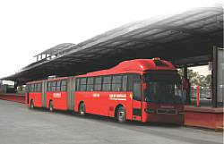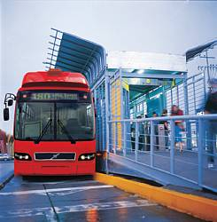
Download picture here Download picture here

