Volvo Bus Corporation
Press Information

IKEA selected Volvo’s hybrid bus in Strasbourg

The IKEA department store in Strasbourg, France, has selected a hybrid bus from Volvo as part of its environmental efforts. The bus will operate a shuttle service for customers to and from the store.

IKEA is continuously trying to reduce the company’s impact on the environment. One way is to encourage and make it easier for more customers and employees to use public transport instead of their own cars when visiting the department store.
Since 2005, the IKEA department store in Strasbourg has offered free bus transportation from the nearest tram stop. This service has attracted more people and in 2010, 127,000 passengers travelled on the free bus.
This year, when it was time to change the bus, IKEA chose to take another step to reduce the environmental impact. Last Monday, the Volvo 7700 Hybrid was put in operation and will depart from the tram stop every 20 minutes. The service is performed by the Cars de Rohan company on behalf of IKEA.
Volvo’s hybrid bus has major environmental benefits, compared with a standard diesel bus. Fuel consumption is up to 35% less and will thus decrease energy consumption and emissions of the greenhouse gas, carbon dioxide, by an equal amount. Other emissions are 45-50% lower than with a diesel bus.
Volvo’s hybrid bus has a small diesel engine and an electric motor, which can be used jointly or independently. The electric motor is driven by battery, which is recharged with brake energy that is utilized when the bus brakes.
One major benefit with Volvo’s hybrid solution is that the diesel engine switches off at the bus stops. The bus restarts using only the electric motor and when the bus reaches 15-20 km/hour, the diesel engine restarts. This creates a silent and exhaust-free environment at bus stops.
Hybrid buses are already in service in France, but this is the first time that a private company will be commencing service using such a bus. The substantial fuel savings with Volvo’s hybrid bus will generate significantly reduced fuel costs and thus make the bus a commercially viable option.
March 18, 2010
For further information, please contact Per-Martin Johansson, press officer, +46 31 322 52 00, per-martin.johansson@volvo.com

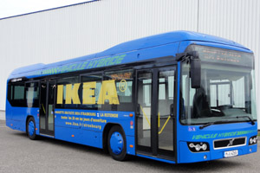 Download picture here

