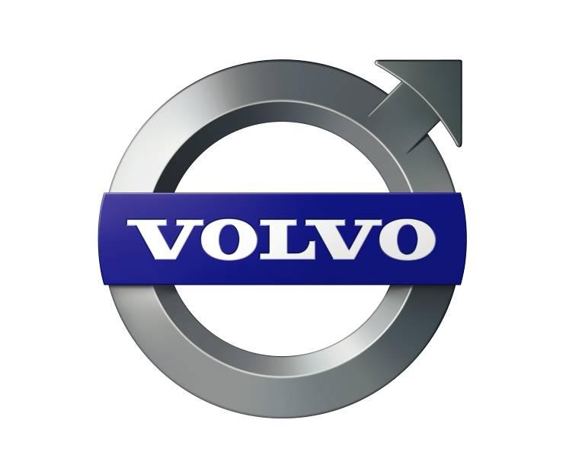

Press Information

Volvo City Bus Trial Begins in Colombo
Volvo Buses today announced the start of road trials for its City Bus in Colombo, Sri Lanka. Hon. Minister of Transport, Mr. Kumara Welgama declared commencement of the trials at a ceremony here. Mr. Dhammika Perera, Secretary, Ministry of Transport and the Chairman of the CTB were also present at the occasion. The dignitaries were given a short experiential ride at Galle Face.
The road trials will begin from July 18, 2011 and will be conducted over one month on select bus routes in Colombo. The proposed bus routes include Moratuwa – Pettah, Kesbewa – Pettah, Negombo – Pettah, Nittambuwa – Pettah, Kaduwela – Fort (via Malambe) and Kottawa – Pettah. The objective of conducting the trials is to attract passengers using individual vehicles to adopt public transportation. This would help in reducing traffic and travel time, besides imparting greater comfort for commuters.
Volvo Buses is a global leader, which is committed to offer the best products designed for public transport across all geographies. Over the years, Volvo has led the way in city based bus transport products, technological innovations and providing solutions for improving systems such as BRT. The company has played a key role in making public transport an attractive option for commuters in rapidly expanding urban locations. Volvo Buses has also taken the lead in deploying eco-friendly products not only introducing the latest technologies but also through implementing sustainable transport concepts, both, in developed and emerging markets
Like all products from the Volvo stable, the Volvo 8400 city bus adheres to the highest quality, safety and technology standards. The high-performance engine has been designed to meet the rigours of city driving conditions. The city bus has the best power-to-weight ratio in its class and a perfectly matched driveline enhances the driving performance. This product typifies the strengths of Volvo in terms of safety, reliability, better performance, optimal operating costs, passenger & driver comfort

13th July 2011
For further information, please contact Satyanarayan Doraiswami, Sr. Manager – Brand Management and Media Relations, +91 99016 53252, satyanarayan.doraiswami@volvo.vom
The role of a modern city bus
The Volvo City Buses play a distinct role. They are specifically positioned as buses that motivate people to move away from their personal vehicles and adopt public transport, which in turn helps in de-congesting the city and improving the traffic conditions.
Volvo City Buses are also changing the way that corporations buy buses. Today, these buses are deployed as part of long-term city plans and based upon the vehicle’s Life Cycle Costs. These buses have an operating life over of over 10 years.
City development plans are increasingly including bus transport system into their long-term investment plan. The objective of creating effective transport systems in cities is to attract owners of private vehicles to switch over to public transport. Such an investment can result in profound savings when it comes to fuel conservation, emissions, safety on the road and most of all helps in decongesting cities.
The Technology behind Volvo 8400 City Bus
Behind the Volvo City Buses’ immense popularity among citizens lies sustainable and modern technology that promises to provide safe and caring transport that lasts a long time through a city’s development phases
These buses bring with them the world’s latest safety features including: Automatic Transmission; Electronic Braking system; anti-roll; front under-run protection device; Disk Brakes; electro-pneumatic safety doors; anti-skid protection, hill start aid with grade ability, brake temperature, warning, poor brake performance warning. Features that help not only to protect passengers but other vehicles on the road too
The automatic transmission assures fatigue-less driving for drivers and a better bus ride for passengers. The low turning radius helps the bus move through crowded traffic with ease. The right power-to-weight ratio of the engine allows quick deceleration & acceleration across various terrains. The retarder system ensures that the bus movement, including braking is almost jerk-free for passengers. The Electronic Air Suspension takes bus comfort to a new level. Of course, the Volvo buses’ in-climate control along with the above features provides an excellent environment to passengers making it a perfect setting to opt for a public transport over personal transport. The bus on trial is disabled friendly, providing easy step less entry and features within for wheel chairs.
Volvo City Buses are today part of most successful city bus systems in the world including India, UK, China, Brazil, Mexico, Finland, Sweden, Singapore and many more.
Volvo Buses in South Asia
Volvo Buses has been in India for more than 9 years and has the richest experience when it comes to high-performing bus applications. This, coupled with its state-of-the-art factory and overall profile of being a complete transport solutions provider, gives it a unique ability to be in the best position to understand the needs of the Indian market and configure products accordingly. Volvo Buses today operates across 12 cities in India, besides Bangladesh and Sri Lanka. It is the second largest European brand with a strong presence in key markets in Asia. At present, there are about 4,000 Volvo Buses operating in the SAARC region, both in the city and inter-city segments.

Volvo Bus Corporation
Volvo Bus Corporation is one of the largest manufacturers of large buses and coaches. The range comprises complete vehicles, chassis, bus bodies, transport system solutions for metropolitan traffic, leasing, financing and service contract maintenance. Volvo Bus Corporation is part of the Volvo Group, one of the world's leading manufacturers of trucks, buses, construction equipment, drive systems for marine and industrial applications, aerospace components and services. The Group also provides complete solutions for financing and service.

