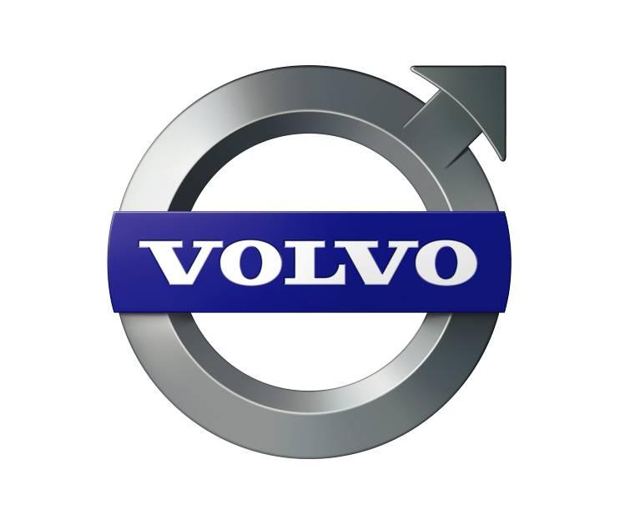

Press Information

The First Volvo CNG City Bus in India is introduced on New Delhi Roads
Volvo Buses today announced the introduction of its first Volvo 8400 Low Floor CNG city bus in Delhi. Smt. Sheila Dikshit, Chief Minister, Delhi flagged off the first bus from the Delhi Secretariat. His Excellency Lars-Olof Lindgren, Ambassador of Sweden to India, and Akash Passey, Managing Director, Volvo Buses India Private Limited were present on the occasion. Ministers and other senior officials from the Delhi Government as well as the senior management of the Delhi Transport Corporation (DTC) were also present at the ceremony.
The Volvo City Bus Experience, already operating in 12 cities of India, will now commence in the national capital through its CNG version. This initiative has been made possible with support from the Delhi Transport Corporation (DTC).
His Excellency Lars-Olof Lindgren, Ambassador of Sweden to India said,“Delhi has done a commendable job by adopting CNG as the fuel option for public transport. They have shown the way for other cities in India that are also eagerly opting for natural gas over other fossil fuels. Volvo has been at the forefront of innovation in mass transport solutions and has always displayed a keen interest in developing vehicles that are beneficial to both the environment as well as public in general. This initiative is another milestone for both the city of Delhi and for Volvo Buses. I am confident that people will realise the benefits of CNG buses and choose public transport in the time to come.”
Akash Passey, MD, Volvo Buses India Pvt Ltd said,“At Volvo Buses we have a responsibility – to make public transport more attractive in order to encourage people to adopt public transport. This is something we have successfully implemented across 12 cities in India. With the Volvo CNG City Bus, we are now advocating both mass transport and environmental benefits to people. Over the years Volvo Buses India has established its credibility in offering the best urban transport solutions. We already have a majority share in the low-floor diesel AC segment, and are confident of consolidating this position with the CNG variant.”
Backed by world-renowned Volvo Technology, this CNG variant of the Volvo city bus is built in India by a highly experienced team of experts from Sweden and India. The availability of CNG variant highlights Volvo’s increasing resourcefulness to cater to dynamic customer needs and drive the change.
The CNG city bus will be built at the state-of-the-art manufacturing plant of Volvo Buses India in Hoskote near Bangalore. Like all products from the Volvo stable, the CNG city bus adheres to the highest quality, safety and technology standards. The high-performance CNG engine has been designed to meet the rigours of city driving conditions. The Volvo 8400 Low Floor CNG city bus has the best power-to-weight ratio in its class and a perfectly matched driveline enhances the driving performance. This product typifies the strengths of Volvo in terms of reliability, better performance, optimal operating costs, passenger & driver comfort and safety.
The CNG variant also houses the new transmission from Volvo - Ecolife, which aims to offer the driver and passengers a superior drive experience. It offers significant fuel reduction opportunities due to a fine-tuned optimised gear system which operates at the most efficient speed ranges in terms of fuel consumption. It has been equipped with intelligent systems to recognise when a vehicle is moving into idle or into gear thereby reducing fuel consumption again. This bus will now have an even stronger retarder system which ensures that the ride is even more jerk-free than ever. There is also far little noise in turn and much lesser heat passed onto the brakes.
Many a details make this product special. For example an active protection to cut off ignition system when refilling, Volvo Electrical System, and high standards of fire protection in the connectors, wiring harnesses and the vehicle multiplex. In case of an unlikely event an automatic fire extinguisher system and also a warning device for driver along with direct control remains in place.
Akash Passey added, “For us at Volvo, bringing the CNG variant is more than just about another fuel. It showcases our intent of being an environmentally responsible organisation committed to drive the change that will be beneficial to all. The Volvo CNG City Bus will create a benchmark for others to follow. ”
Volvo Buses has been in India for more than 9 years and has the richest experience when it comes to high-performing bus applications. This, coupled with its state-of-the-art factory and overall profile of being a complete transport solutions provider, gives it a unique ability to be in the best position to understand the needs of the Indian market and configure products accordingly.
Volvo Buses India today operate across 12 cities in India including Navi Mumbai, Kolkata, Pune, Bangalore, Mysore, Faridabad, Chennai, Thiruvanathapuram, Kochi, and Hyderabad. At present, there are about 3500 Volvo Buses operating in India, both in the city and inter-city segments.

3rd June 2011
For further information, please contact Sohanjeet Randhawa, Head Marketing of Volvo Buses India, +91 98453 97336
Nilanjana Nangia/Ashish Trivedi, Genesis Burson Marsteller +91 9986074334 /+91 99993 84812

Volvo Buses India Private Limited
Volvo Bus Corporation is one of the largest manufacturers of large buses and coaches. The range comprises complete vehicles, chassis, bus bodies, transport system solutions for metropolitan traffic, leasing, financing and service contract maintenance. Volvo Bus Corporation is part of the Volvo Group, one of the world's leading manufacturers of trucks, buses, construction equipment, drive systems for marine and industrial applications, aerospace components and services. The Group also provides complete solutions for financing and service.

The Technology behind the Volvo 8400 CNG City Bus.
Behind the Volvo City Buses’ immense popularity among citizens lies sustainable and modern technology that promises to provide safe and caring transport that lasts a long time through a city’s development phases
Produced in Bangalore at the Volvo Factory, these buses bring with them the world’s latest safety features including: Automatic Transmission; Electronic Braking system; anti-roll; front under-run protection device; Disk Brakes; electro-pneumatic safety doors; anti-skid protection, hill start aid with grade ability, brake temperature, warning, poor brake performance warning. Features that help not only to protect passengers but other vehicles on the road too
The automatic transmission assures fatigue-less driving for drivers and a better bus ride for passengers. The low turning radius helps the bus move through crowded traffic with ease. The right power-to-weight ratio of the engine allows quick deceleration & acceleration across various terrains. The retarder system ensures that the bus movement, including braking is almost jerk-free for passengers. The Electronic Air Suspension takes bus comfort to a new level. Of course, the Volvo buses’ in-climate control along with the above features provides an excellent environment to passengers making it a perfect setting to opt for a public transport over personal transport.
The Volvo City Bus on trial is disabled friendly, providing easy step less entry and features within for wheel chairs.
Volvo City Buses are today part of most successful city bus systems in the world including Bangalore, Pune, Chennai, Mysore, Hyderabad, Navi Mumbai, London, Shangai, Hong Kong, Curitiba, Mexico, Finland, Sweden, Singapore and many more.
The role of a modern city bus
The Volvo City Buses play a distinct role. They are specifically positioned as buses that motivate people to move away from their personal vehicles and adopt public transport, which in turn helps in de-congesting the city and improving the traffic conditions.
Volvo City Buses are also changing the way that corporations buy buses. Today, these buses are deployed as part of long-term city plans and based upon the vehicle’s Life Cycle Costs. These buses have an operating life over of over 10 years.
“City plans are increasingly including buses into their long-term investment plan. This is because there is little purpose to making huge investments on roads if we cannot have the right vehicles and transport systems operating on them. Modern City Buses have a key job to do – attract owners of private vehicles to switch over to public transport. Such an investment can result in profound savings when it comes to fuel conservation, emissions, safety on the road and most of all helps in decongesting cities” mentioned Akash Passey, MD, Volvo Buses India Private Limited.

