Volvo Bus Corporation
Press Information

Order for further 499 Volvo buses for Santiago

Volvo Buses has secured an order for a further 499 buses for the Transantiago transport system in Santiago, Chile. The buses will be manufactured in 2007.

This is the second very large order of Volvo buses for Transantiago in less than two years. In January 2005, Volvo secured an order for 1,779 buses. The buses have been delivered and are now operating in three of the five corridors that comprise Transantiago. The buses covered by the new order will serve a fourth corridor and the customer is the operator Buses Metropolitana.
The new order comprises 171 18.5-meter articulated buses of the Volvo B9 SLFA type, with capacity for 160 passengers and 328 12-meter Volvo B7R LE buses with capacity for 90 passengers. The buses are fitted with 9-liter and 7-liter engines that meet Euro 3 exhaust requirements.

Produced in Brazil and Sweden
The chassis for the articulated buses are being produced at Volvo Buses’ plant in Curitiba, Brazil, and the chassis for the 12-meter buses at Volvo Buses’ plant in Borås, Sweden. The bodywork is being manufactured in Brazil by the Induscar/Caio company.
“The quality of the Volvo brand buses and the company’s strict compliance with the terms and conditions established in the previous deal were decisive factors in winning this other important contract”, declares Per Gabell, president of Volvo Bus Latin America. According to him, the after sales service and the work done by Ditec, the Volvo distributor in Chile also played an important part.
As a result of this order, Santiago becomes the city with the highest number of Volvo articulated buses in the world. Due to their large passenger capacity, the articulated buses are the lynchpin of many of the world’s major modern transport systems, the BRT systems. Volvo Buses is the world’s leading manufacturer of buses for BRT systems. In addition to Santiago, Volvo has also delivered the most buses for the two other very large systems in South America, in Curitiba, Brazil, and Bogota, Colombia.

August 14, 2006
For further information, please contact Per-Martin Johansson, press officer, +46 31 322 52 00 per-martin.johansson@volvo.com

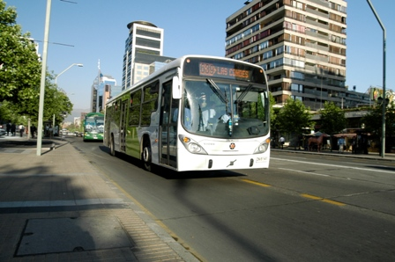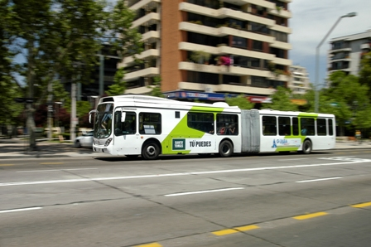

Download picture here Down load picture here

