Volvo Bus Corporation
Press Information

Volvo bus competes in desert rally
A Volvo B7R bus is participating in this year’s run of the tough Budapest-Bamako desert rally. It is the only bus participating in the competition class and it is basically one of the intercity buses that normally operates in Budapest.
The Budapest-Bamako desert rally started in 2005 as an alternative to the Dakar rally. The start is in Budapest, Hungary and the finish in Bamako, the capital of Mali. The route is over the Atlas Mountains in Morocco, across the desert and out along the sea in the Western Sahara and Mauritania and then to the finish in Bamako, including sections along dry riverbeds through Mali.
The rally this year includes 150 4WD cars, trucks, motorcycles as well as an intercity bus from Volvo with 18 passengers. The city bus operator in Budapest, BKV, is marketing the city’s public transport. The bus drivers in the rally are drivers that normally drive the city/intercity buses in Budapest and the bus is basically the same model that operates in the city, a 12-meter Volvo B7R, with body from AlfaBusz. The bus features a 290-hp Euro IV engine.
Obviously, however, some adaptations to the bus were required to handle the toughest stretches. The normal clearance of 340 mm is insufficient so the chassis was raised to 550 mm. Special tires required for driving in the desert contribute to raising the clearance to 650 mm.
Solely rear-wheel drive is not sufficient to tackle the desert sands. Accordingly, the engineers created a solution for variable 4WD. The bus is also equipped with front and rear winches and carries sand anchors and rubber mats if it gets stuck in sanddrifts. The heat requires installation of an extra-large air-intake to the engine.
The chassis is reinforced to support all the equipment required. This includes fuel, water, a diesel generator for electricity, workshop equipment, navigation equipment, radios, medical gear and much more.
“We have provided for sleeping places in the bus for some of the passengers when we overnight in the desert,” says Tibor Mogyorossy at AlfaBusz in Hungary, who will follow along on the trip. “The other passengers will sleep in a tent outside the bus.”

The bus passengers include a number of journalists from the RTL and Eurosport TV channels, for example, who will send daily reports from the rally.
“There is enormous interest in the rally here in Hungary and in many parts of Europe,” says Tibor Mogyorossy. “I am convinced that we will attract a great amount of attention when we compete with a bus in one of the world’s toughest desert rallies.”
This year’s Budapest-Bamako rally starts in Budapest on January 12, with finish in Bamako scheduled for January 27.

January 9, 2008
For further information, please contact Per-Martin Johansson, press officer, +46 31 322 52 00 per-martin.johansson@volvo.com

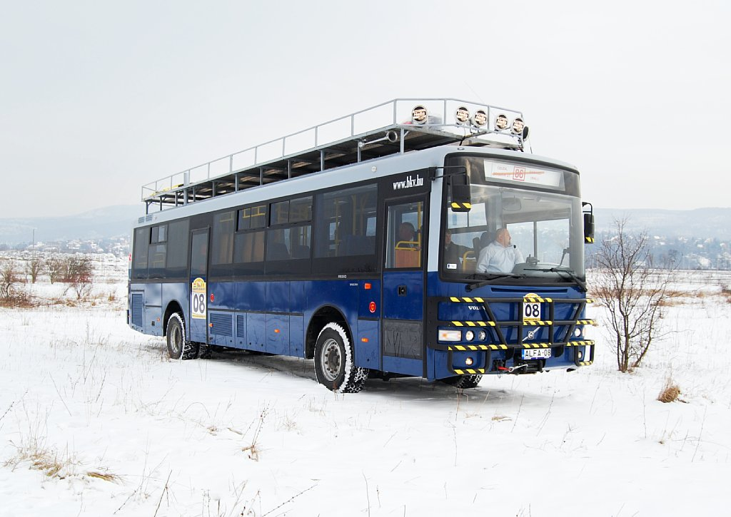
Download high resolution picture

