Volvo Bus Corporation
Press Information

Volvo Buses wins Automotive Technology of the Year award in India

Volvo Buses has received the Automotive Technology of the Year award in India for the Volvo 9400 6x2 coach model. The first three-axle coach in India, it contributes to transport economy and higher passenger comfort.

Considered the most prestigious of all automotive industry awards, the NDTV Car & Bike Awards have grown in significance and in recognition since inception in 2006. Volvo Buses received this award based on critical assessment by a panel of judges comprising leading experts in the automotive field.
Volvo Buses received the technology prize for the Volvo 9400 6x2, a new coach launched in October 2008. It is the first coach with three axles introduced in India and it has contributed to boosting the market for luxury, air-conditioned long-distance coaches in India another step.
“We are very pleased to receive this prestigious award,” says Akash Passey, Managing Director of Volvo Buses in India. ”Technology is paramount for us at Volvo and for us this translates into greater passenger comfort, better transport economy and even higher safety levels.”
Transport economy has improved aided by Volvo’s 9-lityer, 340-hp engine and with a third wheel axle. The standard design of this version of the coach carries eight more passengers, which also contributes to lower fuel economy per passenger. An extra wheel axle also means that riding comfort is higher.
On the safety side, there is for example an electronic braking system and electronically controlled air suspension, features with which Volvo is first in India. The body has reinforced front impact protection, which increases safety for the driver.

March 2, 2009
For further information, please contact Per-Martin Johansson, press officer, +46 31 322 52 00, per-martin.johansson@volvo.com

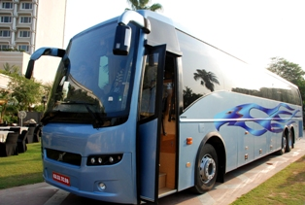 Download picture here

