Volvo Bus Corporation
Press Information

PostAuto operates the Volvo 7700 Hybrid on its rural routes

Now that PostAuto in Switzerland has taken delivery of a Volvo 7700 Hybrid, it is leading the way in hybrid developments. “Most of our routes are in rural areas and Volvo’s parallel hybrid is the only hybrid in the market that appears to have the ability to manage this type of traffic,” says Werner Blatter, a member of executive management at PostAuto.

PostAuto Schweiz AG is Switzerland’s largest bus company with more than 2,000 buses in its fleet.
“With our size, we have a responsibility and the resources to lead the way in terms of testing new solutions, particularly in the area of technology,” says Werner Blatter.
The company has closely monitored developments in the hybrid area, and has seen proof that hybrid buses function well in congested urban traffic. However, PostAuto has most of its routes in rural areas and the hybrids available in the European market are not adapted for this type of traffic.
“However, as soon as Volvo Buses presented its parallel hybrid in autumn 2008 and announced that it was not only well suited for urban traffic but also for stops that were further apart, we did not hesitate to promptly order a bus,” says Werner Blatter.
He foresees two major advantages of hybrid technology; improved fuel economy and reduced environmental impact. For PostAuto, the two are equally important.
“We have demands from politicians and Swiss residents to do our best to reduce energy consumption and environmental impact. At the same time, the company also has profitability requirements. Hybrid technology has the ability to contribute in both areas.”

PostAuto’s new Volvo 7700 Hybrid will be operated by Steinerbus AG, in Ortschwaben outside Bern, one of the many companies that manages traffic on behalf of PostAuto.
“It is incredibly exciting to be the first to have this new hybrid bus,” says owner Dominik Steiner. “My drivers, mechanics and I all enjoy testing new technology and continuously learning.”
At the time of writing, he had only had the bus a few days but he and about 15 of his drivers had already driven it and the first impressions were positive.
“It is not difficult to drive, but has to be driven somewhat differently, slightly more gently, to really capitalize on the regenerative brakes.”
When Volvo Buses launched its hybrid project, the company expected to reduce fuel consumption by up to 35 percent in congested urban traffic and by about 20 percent in exclusively inter-city traffic with stops that were far apart. However, the field tests that were conducted showed that inter-city traffic generates savings of as much as about 25 percent.
“Granted, we have only been driving it a few days to date, but initial calculations indicate that our fuel consumption is about 25-percent lower than with normal diesel buses,” says Dominik Steiner. “If we can maintain this level, it will be very positive.”
April 21, 2010
For further information, please contact Per-Martin Johansson, press officer, +46 31 322 52 00, per-martin.johansson@volvo.com

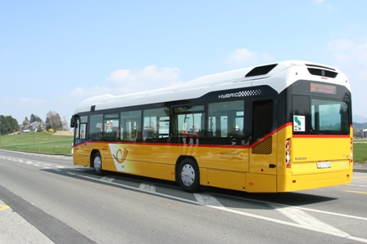 Download picture here

